**CODES AND OUPUTS**

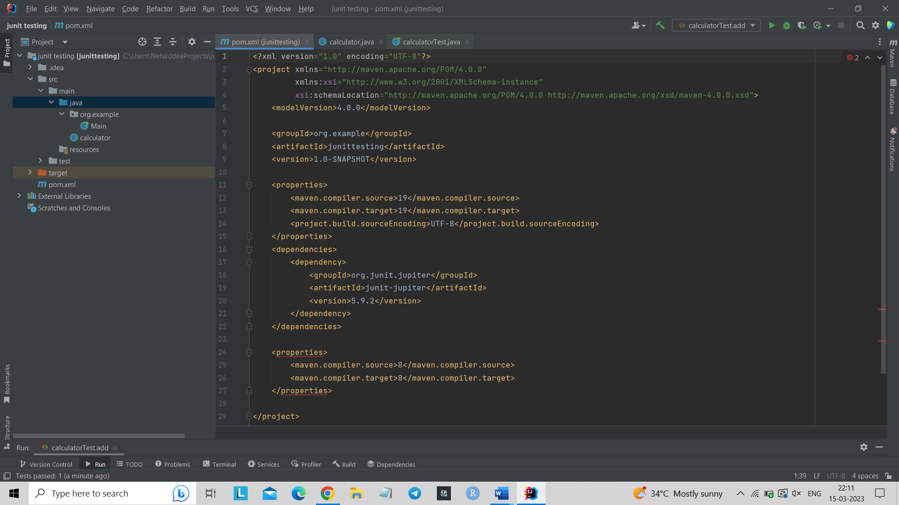

<?xml version="1.0" encoding="UTF-8"?>  
<project xmlns="http://maven.apache.org/POM/4.0.0"  
 xmlns:xsi="http://www.w3.org/2001/XMLSchema-instance"  
 xsi:schemaLocation="http://maven.apache.org/POM/4.0.0 http://maven.apache.org/xsd/maven-4.0.0.xsd">  
 <modelVersion>4.0.0</modelVersion>  
  
 <groupId>org.example</groupId>  
 <artifactId>junittesting</artifactId>  
 <version>1.0-SNAPSHOT</version>  
  
 <properties>  
 <maven.compiler.source>19</maven.compiler.source>  
 <maven.compiler.target>19</maven.compiler.target>  
 <project.build.sourceEncoding>UTF-8</project.build.sourceEncoding>  
 </properties>  
 <dependencies>  
 <dependency>  
 <groupId>org.junit.jupiter</groupId>  
 <artifactId>junit-jupiter</artifactId>  
 <version>5.9.2</version>  
 </dependency>  
 </dependencies>  
  
 <properties>  
 <maven.compiler.source>8</maven.compiler.source>  
 <maven.compiler.target>8</maven.compiler.target>  
 </properties>  
  
</project>

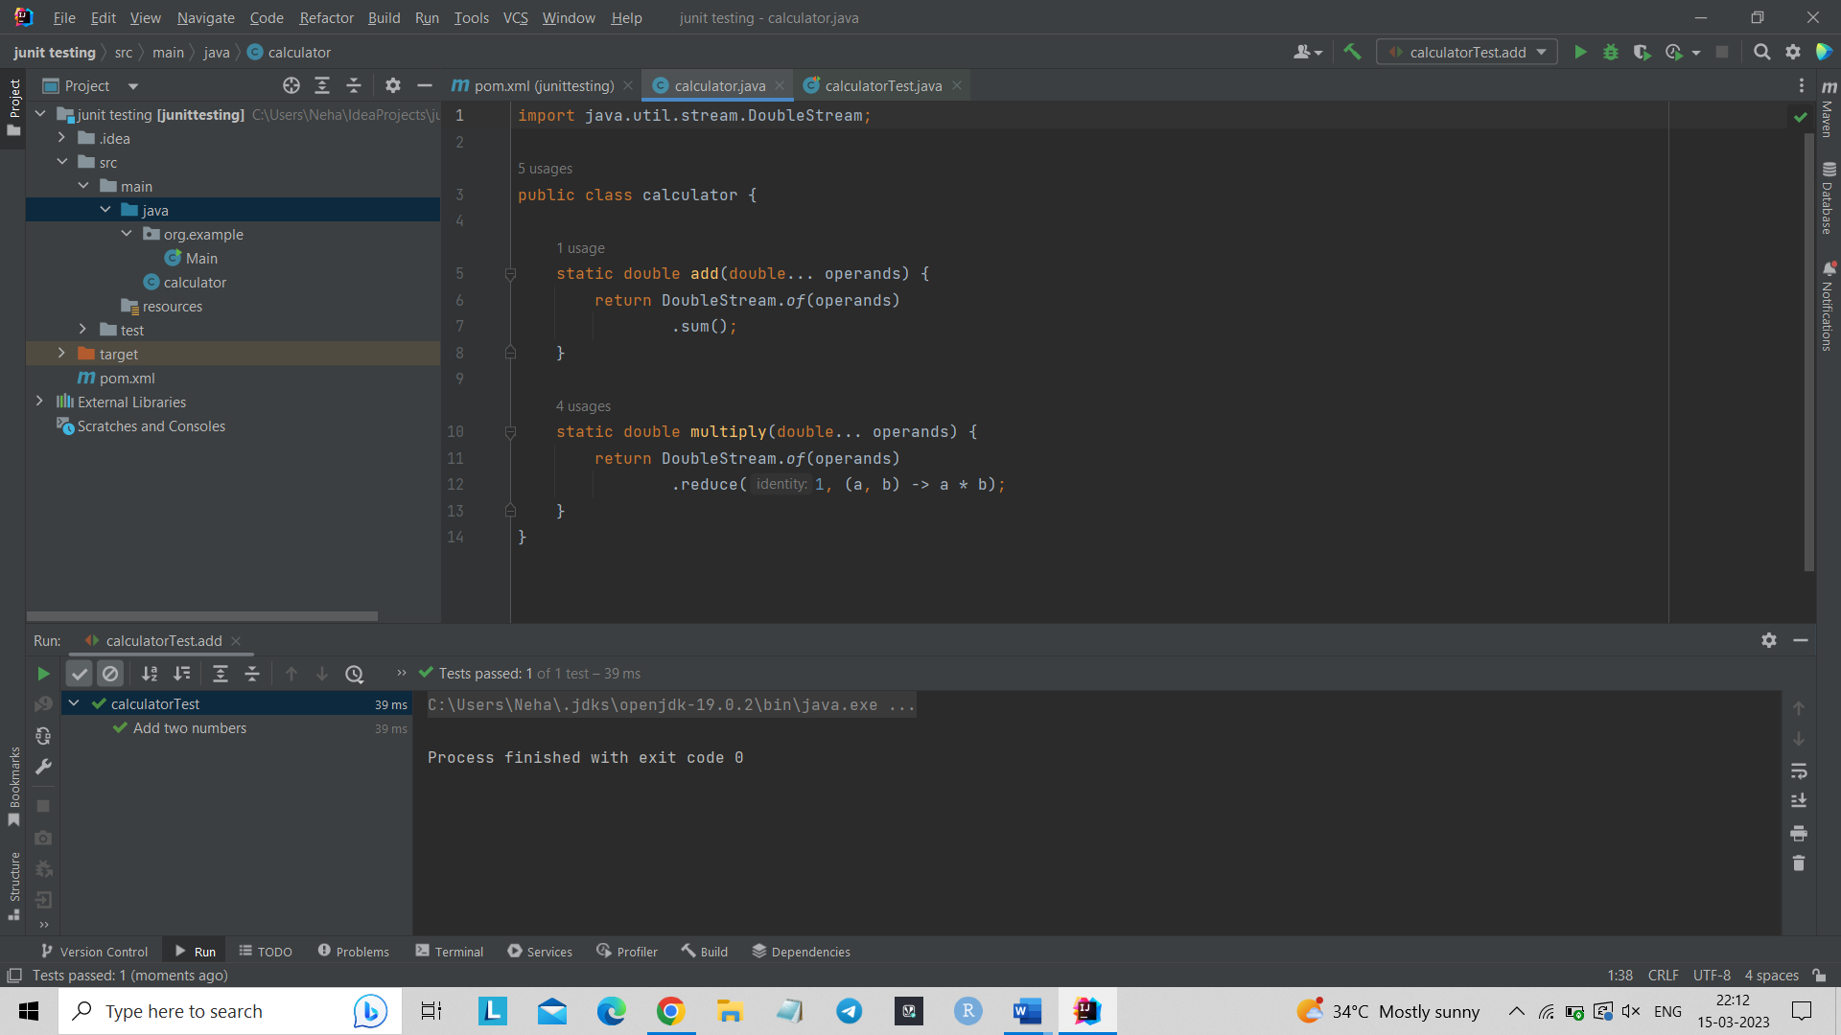

import java.util.stream.DoubleStream;  
  
public class calculator {  
  
 static double add(double... operands) {  
 return DoubleStream.*of*(operands)  
 .sum();  
 }  
  
 static double multiply(double... operands) {  
 return DoubleStream.*of*(operands)  
 .reduce(1, (a, b) -> a * b);  
 }  
}

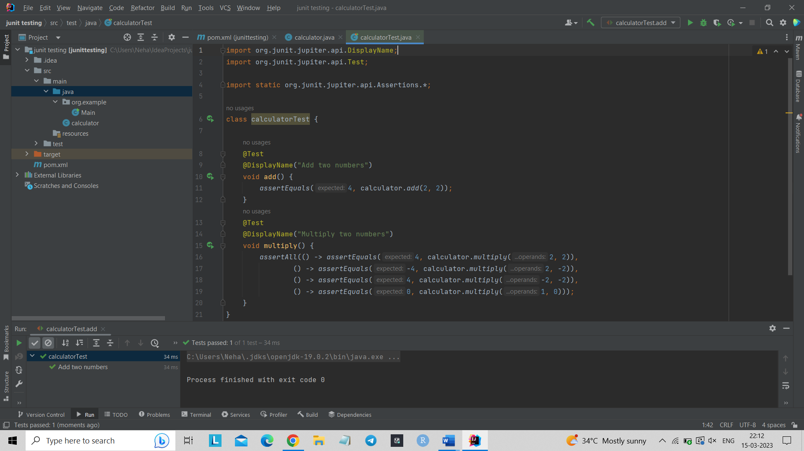

import org.junit.jupiter.api.DisplayName;  
import org.junit.jupiter.api.Test;  
  
import static org.junit.jupiter.api.Assertions.*;  
  
class calculatorTest {  
  
 @Test  
 @DisplayName("Add two numbers")  
 void add() {  
 *assertEquals*(4, calculator.*add*(2, 2));  
 }  
 @Test  
 @DisplayName("Multiply two numbers")  
 void multiply() {  
 *assertAll*(() -> *assertEquals*(4, calculator.*multiply*(2, 2)),  
 () -> *assertEquals*(-4, calculator.*multiply*(2, -2)),  
 () -> *assertEquals*(4, calculator.*multiply*(-2, -2)),  
 () -> *assertEquals*(0, calculator.*multiply*(1, 0)));  
 }  
}

**Addition and multiplication of two numbers** -

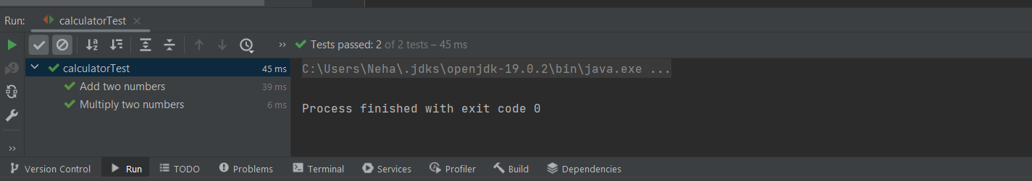

**Addition of two numbers –**

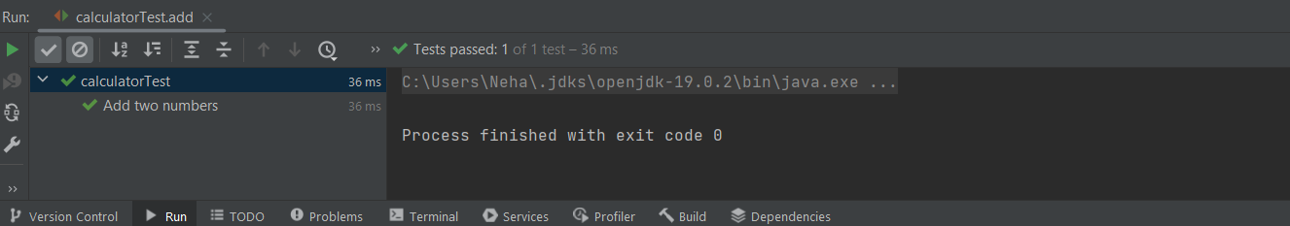

**Multiplication of two numbers –**

